|  |  |
| --- | --- |
| **Project** | Generic – RFID Comms |
| **Title** | Custom Plugin - SiemensRF200_RFID_RS232 |
| **Customer Delivery Date:** | 20/02/2020 |

Version Control

|  |  |  |  |
| --- | --- | --- | --- |
| **Version** | **Date** | **Author** | **Description** |
| 1.0 | 20/02/2020 | N.Sweet | Initial version |
|  |  |  |  |

# General Description

* Plugin to handle both read and write of tags using Siemens RF200 Series
* Can Read &Write Max 20 Characters (Alphanumeric)
* Siemens RF200 Model Uses RS232 communications

# Plugin Presentation

* The plugin step allows you to specify either a READ or WRITE action to be taken
* The Communications Port can be either a suitable USB to RS232 cable with appropriate drivers or if using an Infinity PPC you will need to set one of the existing comm ports to something other than 1-4 as Infinity will try to capture these on startup and the plugin will not be able to access them. For example changing comm port 1 to comm port 5 and using comm port 5 for the plugin will work.
* All actions required by the Siemens RFID reader to apply a READ or WRITE operation are handled internally by the plugin along with any data conversions necessary:
  + Status request
  + Device reset
  + Read From Tag
  + Write To Tag

# Plugin Parameters

* Action: READ or WRITE depending on the requirement
* Comm Port: Must be a valid RS232 based comm port present on the device and visible in Windows Device Manager
* Tag Data: Required to write data to the tag. Maximum 20 alphanumeric characters allowed. You do not have to fill the property with 20 characters – the WRITE mechanism will automatically pad the remaining slots with spaces.

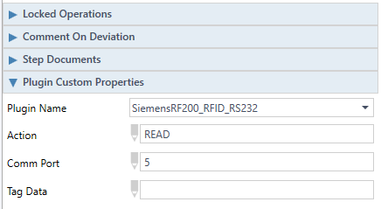

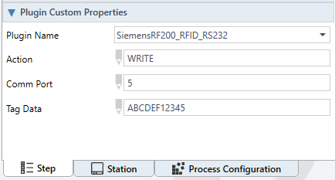

# Plugin Step Outcomes

* For Failures you can also check the Plugin & Infinity Logs

|  |  |  |
| --- | --- | --- |
| DATA | Outcome | Reason |
| ERR0 | Fail | Missing Parameters Supplied To The Plugin |
| ERR1 | Fail | Invalid Action - READ or WRITE |
| ERR2 | Fail | Invalid Comm Port Number |
| ERR3 | Fail | Problem establishing connection to Comm Port |
| ERR4 | Fail | Step Interrupted by External Source |
| ERR5 | Fail | Other Internal Plugin Error |
| Data Written To Tag | Pass | Successful Write To Tag |
| Data Read From Tag | Pass | Successful Read Of Tag |

Note: Data read from tag will have had any trailing spaces removed as follows:

So if you write ABCDE12345 to the tag it will add 10 spaces inside the tag to be 20 characters total.

When you read the same tag you will get exactly ABCDE12345 (10 characters)